**OFFICIAL COORDINATION REQUEST FOR**

**NON-ROUTINE OPERATIONS AND MAINTENANCE**

**COORDINATION TITLE – 16 LWG 13 -** *Lower Granite Dam – Phase 1a JBS Upgrade – Protection Bulkhead Removal*

**COORDINATION DATE –** 08 December 2016

**PROJECT –** Lower Granite Lock and Dam

**RESPONSE DATE –** Friday 09 December 2016

**Description of the problem –** The Lower Granite Dam Juvenile Bypass System (JBS) is currently undergoing an upgrade to improve fish passage through the dam. See FPOM MOC 16 LWG 010 for further details and overall project schedule.

As part of this construction project, a new fish transportation channel is being mined through the south non-overflow section of the dam between Turbine Unit 1 and the adult ladder exit in order to connect the existing juvenile collection channel to the new Primary Dewatering Structure along the south shore tailrace (Figure 1). Prior to initiation of concrete mining and removal to create the new transportation channel, a temporary protection bulkhead was placed on the upstream side of the wall (i.e. in the forebay, see Figures 1 & 2). This protection bulkhead was installed during the 2014/15 winter in-water work window.

As the concrete mining of the new transportation channel has been completed, the construction contractor needs to remove the temporary protection bulkhead in the forebay to proceed with overall construction activities. In order to remove the temporary protection bulkhead, divers will need to enter the forebay, between Turbine Unit 1 and the adult ladder exit.

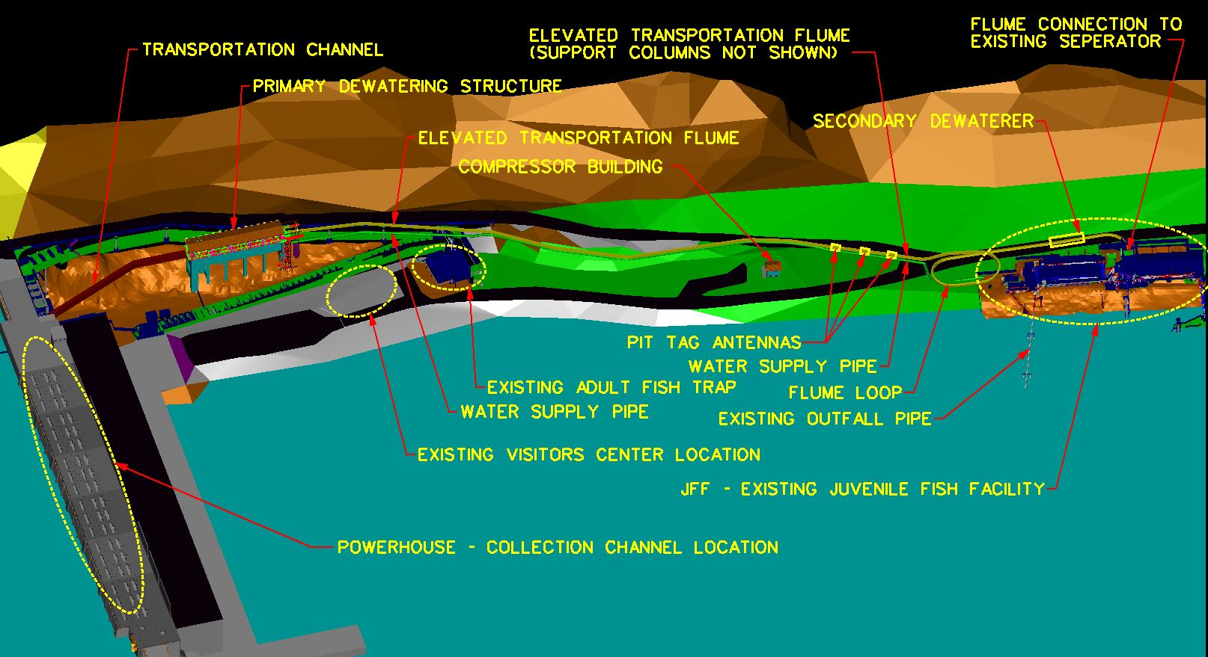

Figure 1. Depiction of overall Lower Granite Dam JBS Phase 1a upgrade. Red line in forebay indicates location of protection bulkhead. Red arrow indicates general location of ladder exit and diffuser 14 intake.

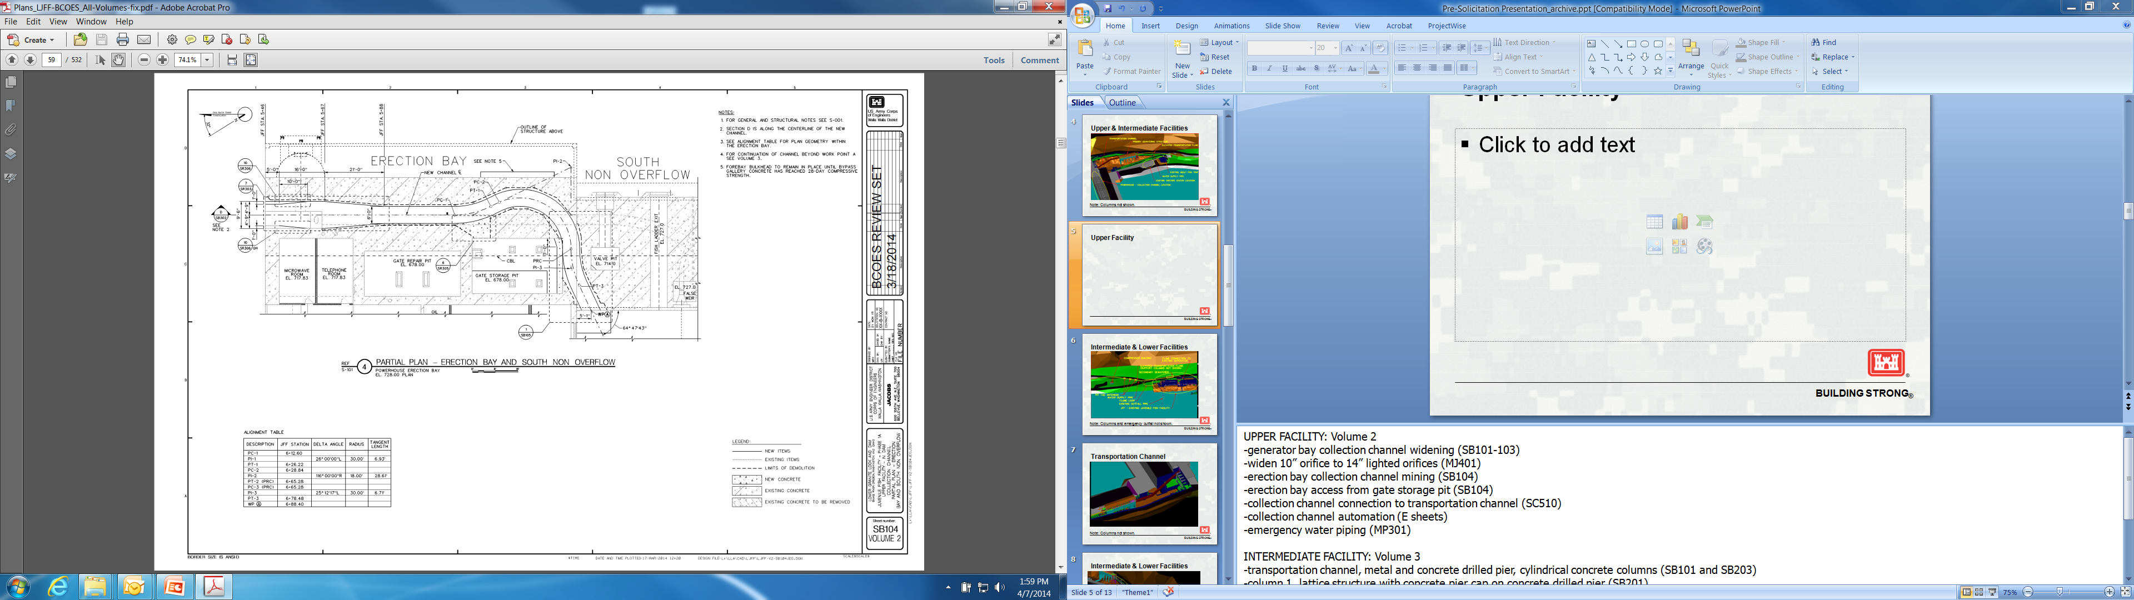

Figure 2. Depiction of routing for new transportation channel being installed at Lower Granite Dam. Horizontal red line indicates location of protection bulkhead in the forebay. Red arrow indicates location of Diffuser 14 intake with arrow pointing towards forebay. Hollow red box indicates location of adult ladder exit.

**Type of outage required –** In order to remove the protection bulkhead, diffuser 14, which feeds water to the middle of the adult ladder, needs to be temporarily shut off to ensure that divers will have a safe forebay environment to work in. The adult ladder exit will remain open during this process. No diving will occur in front of the adult ladder exit itself.

**Impact on facility operation –** The Project will turn off diffuser 14 for the duration of the temporary protection bulkhead removal process to ensure diver safety. The entire temporary bulkhead removal process will be completed during the day to ensure this removal can be done in a safe manner. A variety of equipment will be setup on the intake deck including dive equipment and at least two mobile cranes.

**Dates of impacts/repairs –** The temporary protection bulkhead will be removed on 13 December 2016. If problems arise, or additional time is needed, removal of the bulkhead will be completed during the day of 14 December 2016.

**Length of time for repairs –** It is anticipated that the protection bulkhead can be removed in one day shift (<= 8 hours) with 3-4 hours of dive time. However it is possible that a second shift could be required to remove the protection bulkhead if complications with removal arise. Diffuser 14 will need to be kept offline during the removal process for diver and equipment safety. Diffuser 14 will be shut off and tagged out, following lock-out-tag-out procedures at the beginning of the removal process.

**Expected impacts on fish passage –** Impacts to adult salmon passage associated with this 1-2 day operation are expected to be minimal. The work will be completed with diffuser 14 anticipated to be turned off and returned to service within 8 hours. The adult ladder will continue to operate with gravity flow such that the overflow weirs will be out of criteria however the ladder will otherwise remain watered up. Fish can safely remain in the ladder and pass through submerged orifices and entrances/exit if desired.

Steelhead are typically the only adult fish moving through the Lower Granite ladder at this time with an median run size of 977 and average run size of 1,336 steelhead passing Lower Granite during December (Figure 3). Steelhead passage past Lower Granite has been trending below the historical averages during the 2016 passage season further reducing the potential level of impact.

Activities on the intake deck will include crane use to lift divers and the temporary bulkhead in/out of the water. In-water activities, including use of handheld tools to unbolt the temporary protection bulkhead and attach it to cables for lifting by a mobile crane, will occur approximately 50-150+ feet from the adult ladder exit. Therefore, there is limited potential for passing fish to be impacted by noise and vibrations associated with the removal of the temporary protection bulkhead. Additionally, the limited number of fish that may be near the ladder exit will be able to remain in the ladder, descend the ladder, or swim into the forebay during these bulkhead removal activities. As a result, the maximum potential impact is anticipated to be a passage delay of several hours for fish in the ladder on 13/14 December.

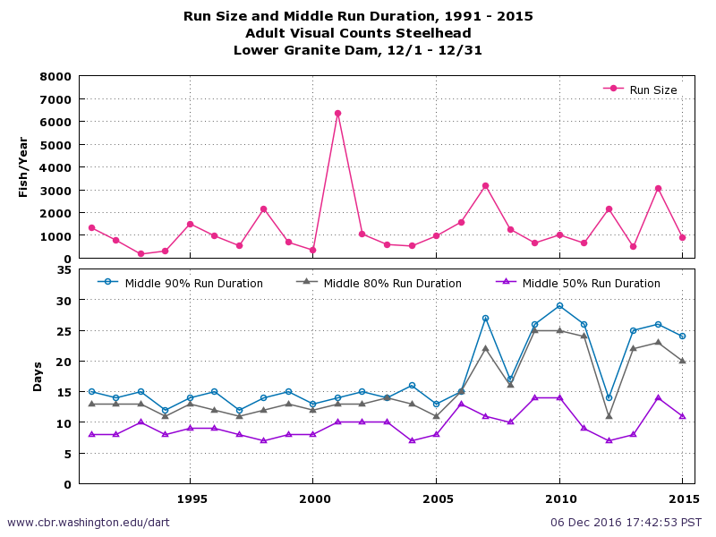

Figure 3. Steelhead run size during December at Lower Granite Dam for 1991 to 2015 based on visual counts.

**Comments from agencies**

**Final results**

Please email or call with questions or concerns.

Thank you,

David Trachtenbarg

Fish Biologist

Environmental Analysis Section

U.S. Army Corps of Engineers

Walla Walla District

201 N 3rd Ave.

Walla Walla, WA 99362

Phone: 509-527-7238

David.A.Trachtenbarg@usace.army.mil